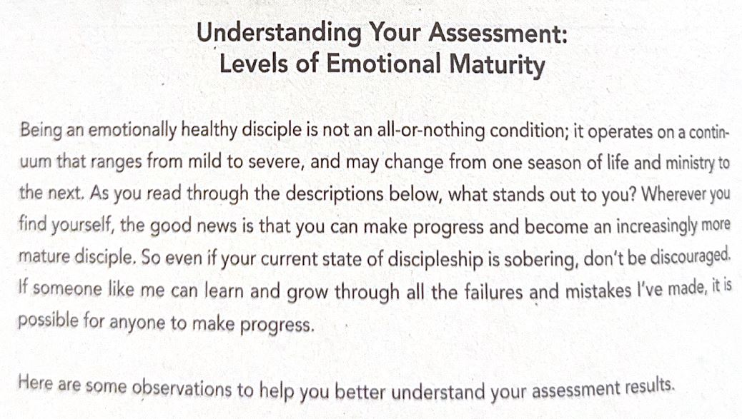

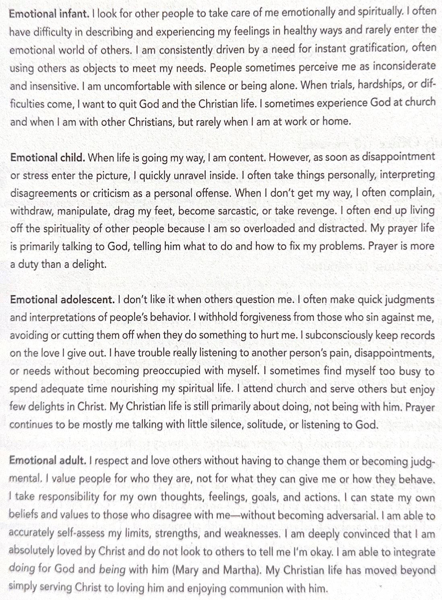

Peter & Geri Scazzero, in Emotionally Healthy Relationships, Pgs. 22-23, Harper Christian Resources, 2021

